Create a QRCode using Zxing

* Import JAR files to a project
* Create a qrcode
* Save the qrcode

# Setup

* Download the javaZxing.zip file file from weekly learning resources
* Extract
* Build a new Java project called BuildQRCode
* Delete the main and add a JFRame

# What is a JAR file?

* A JAR file (Java Archive)
* File that contains classes, files, and images
* Allows for easy distribution of multiple classes
* Added to Java projects to extend the existing imports
* Every time you build your project, you generate a JAR file
* Stored in the dist folder

# Use the JAR file in another project

* Rt Click Libraries
  + Select add library for demo
  + Talk about what is here
* Rt Click Libraries
* Select Add JAR/Folder
* Browse to your downloaded ZXing JAR files and select them
  + Core.jar
  + Javase.jar

# Build the JFrame

* 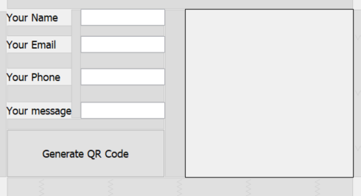Create JLabels and JFrames with whatever you want in the QRcode
  + At least two objects please (name and phone)
* Add button to draw
  + If time demo menu bar
* Add Panel called qrPanel

# Build the code

We will draw onto the panel rather than the entire frame

* Override paint
* Add these variables to start
* 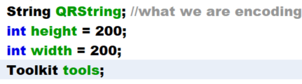
* Add to constructor  
  
* Link the panel to a drawing object
  + Add this variable to the top  
    
  + Add this line to constructor – drawing onto the panel instead of the frame  
    

# Draw the qrCode

* Add these variables  
  
* Accept default – if error, you did not import he JAR files right  
  
* Go to button code
* Gather the onscreen objects  
  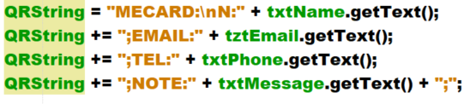
* Add these imports  
  
* Build the image in memory
* 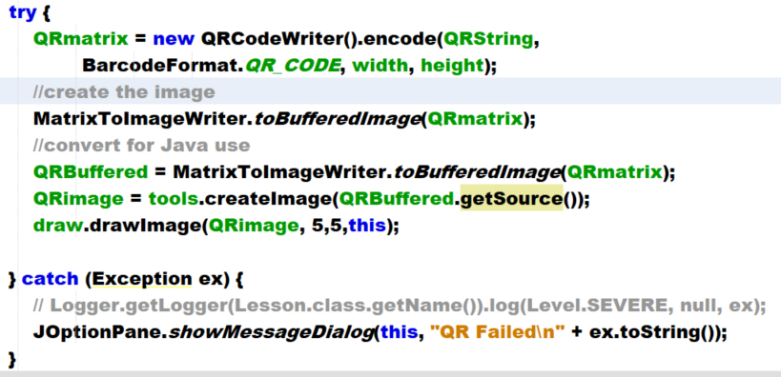
* Ensure it draws – add to paint  
  

# Save the file to disk

* Add a button to save

